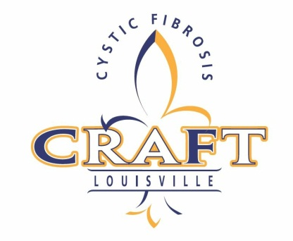
•CRAFT•
RESTAURANT PARTICIPATION FORM

Restaurant Name:
Contact Name:
Address:
City, State, Zip:
Phone: Fax:
Contact Email:
Restaurant Website:

I agree to participate as a Restaurant Tasting In-Kind Sponsor for CRAFT on October 10, 2015. I will have a table, plates, napkins and staff for my booth to serve the 500 samples and will provide collateral promoting my restaurant.

I need the following provided for me __________________________________________
*Food must be pre-prepared.

Signature: Date:

Item Description:

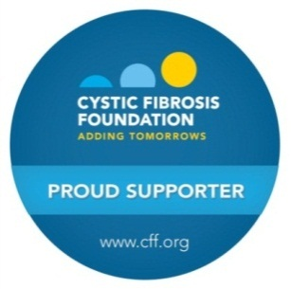
Please return to Cure CF, Inc:
11405 Vista Club Drive
Louisville, KY 40291
CureCFInc@gmail.com
PHONE: (502) 608-9049

Important note on attendance for people with CF and their families:
The health and well-being of people with Cystic Fibrosis is our top priority. Medical evidence shows that certain bacteria can be passed between individuals who have CF and can lead to worse symptoms and speed decline in lung function. To limit the serious risk of cross-infection between people with CF, at any outdoor event, people with CF should maintain a distance of at least 6 feet from each other. For more information, please call us at 502-619-4059.

