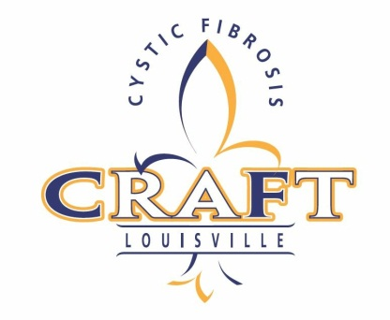
•CRAFT•
BREWERY PARTICIPATION FORM

Brewery Name:
Contact Name:
Address:
City, State, Zip:
Phone: Fax:
Contact Email:
Website:

Breweries to facilitate 2 or more beer styles, cooling system, gas, one or two 6-8 ft tables, signage, a brewery representative, and volunteer pourers if possible.

Signature: Date:

*Please provide a description of what you are intending to serve. This helps us ensure a variety of tastings and an opportunity to highlight your item in press releases.

Item Description:
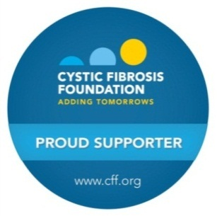
Please return to Cure CF, Inc:
Jonathan Foushee
10500 Fairmount Falls Way
Louisville, KY 40291
Jdfoosh357@aol.com

Important note on attendance for people with CF and their families:
The health and well-being of people with Cystic Fibrosis is our top priority. Medical evidence shows that certain bacteria can be passed between individuals who have CF and can lead to worse symptoms and speed decline in lung function. To limit the serious risk of cross-infection between people with CF, at any outdoor event, people with CF should maintain a distance of at least 6 feet from each other. For more information, please call us at 502-619-4059.

